Book

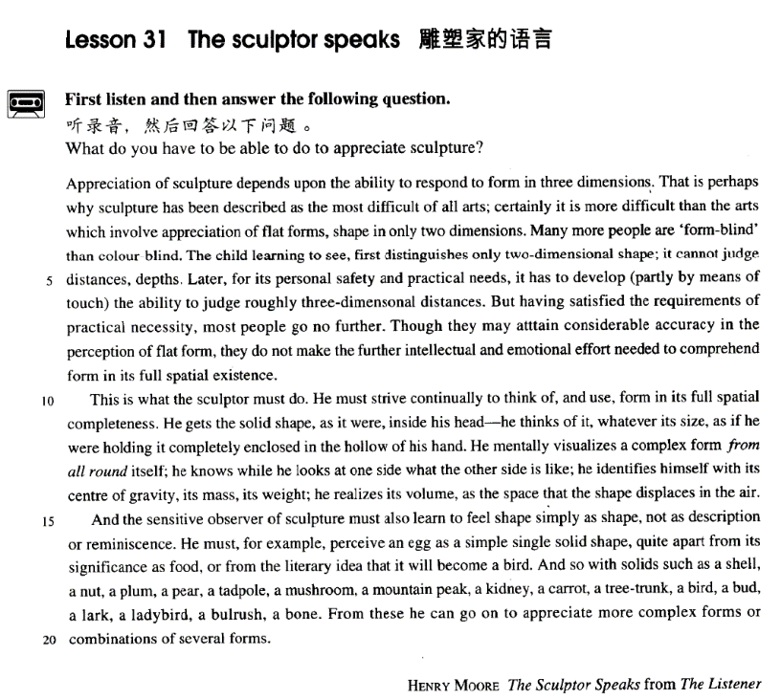

课文

Appreciation of sculpture depends upon the ability to respond to form in 3 dimensions.

对雕塑的鉴赏力取决于对立体的反应能力。

That is perhaps why sculpture has been described as the most difficult of all arts;

雕塑被说成是所有艺术中最难的艺术，可能就是这个道理。

certainly it is more difficult than the arts which involve appreciation of flat forms, shape in only two dimensions.

欣赏雕塑品当然比欣赏平面的艺术品要难。“

Many more people are 'form-blind' than colour-blind.

形盲”的人数比“色盲”的人数要多得多。

The child learning to see, first distinguishes only two-dimensional shape; it cannot judge distances, depths. Later, for its personal safety and practical needs, it has to develop (partly by means of touch) the ability to judge roughly 3-dimensonal distances.

正在学看东西的儿童起初只会分辨二维形态，不会判断距离和深度。慢慢地，由于自身安全和实际需要，儿童必须发展（部分通过触觉）粗略判断三维空间距离的能力。

But having satisfied the requirements of practical necessity, most people go no further.

但是。大部分人在满足了实际需要后，就不再继续发展这种能力了。

Though they may attain considerable accuracy in the perception of flat form,

虽然他们对平面形的感觉能达到相当准确的程度，

they do not make the further intellectual and emotional effort needed to comprehend form in its full spatial existence.

但他们没有在智力和感情上进一步努力去理解存在于空间的整个形态。

This is what the sculptor must do. He must strive continually to think of and use, form in its full spatial completeness.

而雕塑家就必须做到这一点。他必须勤于想像并且利用形体在空间中的完整性。

He gets the solid shape as it were, inside his head -- he thinks of it, whatever its size, as if he were holding it completely enclosed in the hollow of his hand.

可以说，当他想像一个物体时，不管其大小如何，他脑子里得到的是一个立体的概念，就好像完全握在自己手心里一样。

He mentally visualizes a complex form from all round itself;

他的大脑能从物体周围的各个角度勾画出其复杂的形象，

he knows while he looks at one side what the other side is like; he identifies himself with its centre of gravity, its mass, its weight;

他看物体的一边时，便知道另一边是个什么样子。他把自身和物体重心、质量、重量融为一体。

he realizes its volume as the space that the shape displaces in the air.

他能意识到物体的体积，那就是它的形状有空气中所占的空间。

And the sensitive observer of sculpture must also learn to feel shape simply as shape, not as description or reminiscence.

因此，敏锐的雕塑观赏者也必须学会把形体作为形体来感觉，不要靠描述和印象去想象。

He must, for example, perceive an egg as a simple single solid shape quite apart from its significance as food, or from the literary idea that it will become a bird.

以鸟蛋为例。观赏者必须感觉到它是一个单一的实体形态，而完全不靠它的食用意义或它会变成鸟这样的文字概念来感觉。

And so with solids such as a shell, a nut, a plum, a pear, a tadpole, a mushroom, a mountain peak, a kidney, a carrot, a tree-trunk, a bird, a bud, a lark, a ladybird, a bulrush, a bone.

对于其他实体，如，贝壳、核桃、李子、梨子、蝌蚪、蘑菇、山峰、肾脏、胡萝卜、树干、鸟儿、花蕾、云雀、瓢虫、芦苇以及骨头也应这样来感觉。

From these he can go on to appreciate more complex forms or combinations of several forms.

从这些形体出发，观赏者可进一步观察更为复杂的形体或若干形体的组合。

词汇讲解

Lesson 31The sculptor speaks

perception [pə'sepʃn]

n. 知觉，感知能力；洞察力；看法

perception n. 1. [U] (fml.) ability to see, hear or understand 知觉，感知能力

visual perception

our perception *of* reality

Though they may attain considerable accuracy in the perception *of* flat form, they do not make the further intellectual and emotional effort needed to comprehend form in its full spatial existence.

perception n. 2. [U] (fml.) the ability to understand the true nature of sth.

= insight 洞察力

His analysis of the problem showed great perception.

perception n. 3. [C] the way you think about sth. and your idea of what it is like 看法

My perception *of* the matter is that ...

the public perception *of* the government's performance perceive v. 觉察到，注意到；理解

perceptible adj. 可觉察的，可感知的

perceptive adj. 敏锐的，有洞察力的

“ceive” / “cept” / “cip” / “cipate” = to take perception “per” = through

perceive perceptible perceptive accept “ac” = to

acceptable acceptance

deceive v. “de” = away

deception deceptive except “ex” = out

exception exceptional intercept “inter” = between interceptor interception receive “re” = back

reception receipt receptionist anticipate “anti” = before

anticipation anticipatory participate “part” = part

participant participation emancipate “e” = out “man” = hand susceptible “sus” = under comprehend [7kɒmprɪ'hend]

v. 完全理解

comprehend v. understand sth. fully 完全理解

How could you possibly comprehend the difficulties of my situation? “prehend” / “prehens” = to seize

comprehend “com” = together comprehension n. 完全理解comprehensive adj. 包罗万象的，全面的

apprehend “ap” = to v. 逮捕

apprehension n. 逮捕；忧虑，恐惧apprehensive adj. 忧虑的，害怕的，不安的reprehend “re” = back v. 批评，指责reprehension n. 批评，指责

reprehensible adj. 应受指责的

visualize ['vɪʒuəlaɪz]

v. 设想，想象

visualize v. to form a picture of someone or something in your mind = imagine 设想，想象

I tried to visualize the house while he was describing it.

I’m just trying to visualize how this hat would look with my new dress. imagine

We sometimes imagine a desert island to be a sort of paradise where the sun always shines.

Imagine their dismay when they found a beautifully-cooked wallet and notes turned to ash!

picture

I can't picture the village without the old church.

We found it hard to picture him as the father of teenage sons. form a picture of …

It is very difficult to form a picture of life in the 6th Century because there is a lack of historical evidence.

Most of us have formed an unrealistic picture of life on a desert island. conceive of …

Can you conceive of a situation in which the United States would ever have to use its nuclear arsenal?

I have often tried to conceive of what those pages might contain, but of course I cannot do so because I am a prisoner of the present-day world, just as all of you are.

reminiscence [7remɪ'nɪsns]

n. 回忆，回忆录

reminiscence n. 1. [U] recalling of past events and experiences 回忆，怀

旧

And the sensitive observer of sculpture must also learn to feel shape simply as shape, not as description or reminiscence.

reminiscences n. [pl] spoken or written account of one’s remembered experiences 回忆，回忆录

The novel contains endless reminiscences *of / about* the author's youth.

reminisce v. to talk or think about pleasant events in your past 缅怀往事， 话旧

reminisce about …

We spent a happy evening reminiscing about the past.

memoirs n. [pl.] a book by someone important and famous in which they write about their life and experiences 回忆录，自传

Lady Thatcher had just published her memoirs.

memo / memorandum n. a short official note to another person in the same company or organization 备忘录

I sent him a memo reminding him about the meeting.

Appreciation of sculpture depends upon the ability *to respond to form in*

*there dimensions*. appreciation of … 欣赏……

appreciation of poetry and literature

in appreciation of … 以感谢……

I sent him a gift in appreciation of his help. appreciation of … 理解……

To get a full appreciation of what this means we must turn first to some

recent human inventions.

That is perhaps why sculpture has been described as the most difficult of all arts; certainly it is more difficult *than the arts which involve appreciation of flat forms, shape in only two dimensions*.

the most difficult of all arts

➔ the most difficult art of all

the greatest of all Western stars

➔ the greatest Western star of all

the most difficult of all obstacles

➔ the most difficult obstacle of all

the most valuable find of all

➔ the most valuable of all finds

the most frightening thing of all

➔ the most frightening of all things

the deepest holes of all

➔ the deepest of all holes

involve v. if a situation, an event or an activity involves sth, that thing is an important or necessary part or result of it 需要……

involve (doing) sth.

Community service can involve anything from gardening to helping in old people's homes.

Jane was on a diet which involved eating nothing but fruit. entail (doing) sth.

This job entails a lot of hard work.

My job entailed being on call twenty-four hours a day. Many more people are 'form-blind' *than colour-blind*. many / far more + 复数名词

much / far more + 不可数名词

many / far more people much / far more money

The child learning to see, first distinguishes only two-dimensional shape; it cannot judge distances, depths.

Later, *for its personal safety and practical needs*, it has to develop *(partly*

*by means of touch)* the ability to judge roughly three-dimensional

distances.

But having satisfied the requirements of practical necessity, most people go no further.

go further 更进一步

I can offer you 50, but I can't go any further than that.

Whaling in Australia was stopped. But the Australian government went further and proposed a global ban.

Though they may attain considerable accuracy in the perception of flat

form, they do not make the further intellectual and emotional effort

*needed to comprehend form in its full spatial existence*.

spatial adj. relating to the size, shape, and position of things, and the relation of objects to each other in space 空间的

changes taking place in the spatial distribution of the population

the development of a child's spatial awareness This is the oldest Hebrew manuscript in existence.

造句：尽管人们可以相当精确地感知金钱的力量，但是他们之中的大

多数在智力上和情感上却没有进一步努力去理解人生的意义。Though people may attain considerable accuracy in the perception of the power of money, most of them do not make the further intellectual and

emotional effort needed to comprehend the meaning of life.

造句：尽管我们可以相当精确地衡量物质商品的价值，但是我们之中多数人在智力和情感上却没有进一步努力去估算人们为我们做的服务的真正价值。

Though it may be possible to measure the value of material goods in terms of money, it is extremely difficult to estimate the true value of the services which people perform for us.

造句：尽管我们可以相当精确地衡量物质商品的价值，但是我们之中多数人在智力和情感上却没有进一步努力去估算人们为我们做的服务的真正价值。

Though we may attain considerable accuracy in the measurement of the value of material goods, most of us do not make the further intellectual and emotional effort needed to estimate the true value of the services which people perform for us.

This is what the sculptor must do.

He must strive continually to think of, *and use*, form in its full spatial

completeness.

strive v. try very hard to obtain or achieve sth.（为获得或实现某事物） 努力，奋斗

strive to do sth.

We strive to be accurate, but some mistakes are inevitable. strive for …

women who were striving for more freedom think of sth. = imagine sth. 想像某事物Just think of the expense!

He gets the solid shape, *as it were*, inside his head―he thinks of it,

*whatever its size*, as if he were holding it *completely enclosed in the*

*hollow of his hand*.

as it were / so to speak 好像

They will be able, as it were, to see and hear us in action.

It is said that the nerve poison is the more primitive of the two, that the blood poison is, so to speak, a newer product from an improved formula. whatever 引导让步状语从句时，常省略 be 动词。

He gets the solid shape, as it were, inside his head-he thinks of it,

whatever its size (is), as if he were holding it completely enclosed in the hollow of his hand.

Whatever the source of noise (is), one thing is certain: silence, it seems, has become a golden memory.

After all, whatever her faults (are), she is your mother. The country is always beautiful whatever the season (is).

It is as if a single unimportant event *set* up a chain of reactions.

It's as if they *were* in some sense cosmic beings in violent an lovely contrast with us suburban creatures.

…, but I do not turn for protection to dreary clichés about respect of elders, as if mere age *were* a reason for respect.

Gesticulating wildly, the man acted as if he *found* my offer outrageous, but he eventually reduced the price to ₤10.

Speculations about its nature have been going on for literally thousands of years, and one odd finding that makes the problem puzzling is that it

looks very much as if sleeping *is* not simply a matter of giving the body a rest.

hollow n. a place in something that is at a slightly lower level than its surface 凹陷处

The dog found a hollow in the ground to hide in from the wind.

She held the small bird in the hollow of her hand.

He mentally visualizes a complex form *from all round* itself; he knows while he looks at one side what the other side is like; he identifies himself with its centre of gravity, its mass, its weight; he realizes its volume, *as the space that the shape displaces in the air*.

Towards midday, a girl heard a muffled cry coming from *behind one of*

*the walls*.

I took my watch from *under the pillow*. We didn’t meet until *after the show*.

The weather has been fine except *in the north*.

identify … with … 把……与……联系起来，把……和……等同起来

One cannot identify happiness with wealth. Never identify opinions with facts.

He refused to identify himself with the new political party.

The politician is too closely identified with the former government to become a minister in ours.

displace v. to take the place of sb. or sth. 代替，取代

Gradually factory workers have been displaced by machines.

And the sensitive observer of sculpture must also learn to feel shape simply as shape, not as description or reminiscence.

He must, *for example*, perceive an egg as a simple single solid shape,

*quite apart from its significance as food, or from the literary idea that it*

*will become a bird*.

perceive … as … 把……当做是……，认为……是…… She did not perceive herself as disabled.

Computers were often perceived as a threat.

Even as a young woman she had been perceived as a future chief executive.

apart from 1. except for 除了……

I've finished apart from the last question. apart from 2. besides 除了……（还……）

Apart from their house in London, they also have a villa in Spain.

apart from 3. separate from 脱离开……

There can be no knowledge apart from practice.

You can hardly consider the one apart from the other.

And so with solids such as a shell, a nut, a plum, a pear, a tadpole, a mushroom, a mountain peak, a kidney, a carrot, a tree-trunk, a bird, a bud,

a lark, a ladybird, a bulrush, a bone.

And he must also feel shape simply as shape, not as description or reminiscence with solids such as a shell, a nut, a plum, a pear, a tadpole, a mushroom, a mountain peak, a kidney, a carrot, a tree-trunk, a bird, a bud, a lark, a ladybird, a bulrush, a bone.

From these he can go on to appreciate more complex forms *of combinations of several forms*.

go on to do sth. 继续做下一件事

go on with sth. 继续做同一件事

go on doing sth. 持续做某事

What proportion of people who are HIV-positive go on to develop AIDS? Please go on with what you're doing and don't let us interrupt you.

In many ways, this is unfortunate for the poor actors who are required to go on repeating the same lines night after night.